CHAPTER 1. OVERVIEW

1.1. Project Information
This report presents the software-testing study and final submission for the Online Sales Management System, a web-based business application developed on ASP.NET Core MVC (.NET 8). The system is designed to support core sales and inventory operations, including user authentication, product management, supplier management, customer management, purchase handling, invoice processing, stock monitoring, reporting, and public product browsing.
The main purpose of this project is to evaluate whether the system behaves correctly in its business-critical workflows and whether the final submission satisfies the course requirements for test planning, test-case design, execution evidence, bug management, reporting quality, and basic automation. The testing effort was conducted using a combination of manual testing, API testing, and targeted automation. All major claims in this report are supported by execution artifacts such as screenshots, Excel workbooks, automation outputs, runner files, GitHub Issues, and a recorded automation video.
From a quality-assurance perspective, this project is suitable for software-testing assessment because it contains multiple functional surfaces and several high-risk business rules. In particular, purchase and invoice workflows directly affect inventory data, role-based access control determines which screens each user can reach, and product import introduces validation and bulk-processing risks. These characteristics make the system appropriate for structured scenario design, execution, defect reporting, and evidence-based analysis.

1.1.1. System overview
The Online Sales Management System is an internal-and-public web application that supports both operational users and public visitors. The internal area provides a secured administrative interface where authorized users can manage products, suppliers, customers, purchases, invoices, stock records, and business reports. The public area provides product discovery features for browsing, filtering, sorting, and viewing product details.
The system follows a layered ASP.NET Core MVC architecture and relies on a relational database for persistent storage. Authentication and authorization are handled through ASP.NET Identity, while the database layer is implemented through Entity Framework Core. In addition to the browser-based interface, the system exposes a limited API surface used for service health checking and catalog retrieval. This combination of UI-driven workflows and request-response APIs gives the testing team a broad but manageable target for both manual and automated verification.
For the purpose of the final submission, the system was tested as a locally executed environment using seeded demo data. This allowed the team to verify realistic workflows such as valid login, invalid login, role restrictions, product creation, purchase draft creation, invoice processing, stock-related views, reporting filters, product import validation, and catalog API behavior. The system therefore represents a practical case study for end-to-end software testing rather than a purely theoretical exercise.
Table 1.1. System overview
Item | System description
System name | Online Sales Management System
System type | Web-based sales and inventory management system
Architecture style | ASP.NET Core MVC application with database-backed business workflows
Primary users | Administrative users and public catalog visitors
Main interfaces | Admin UI, Public UI, Health API, Catalog API
Testing objective | Verify business-critical workflows, validation behavior, permissions, and API responses

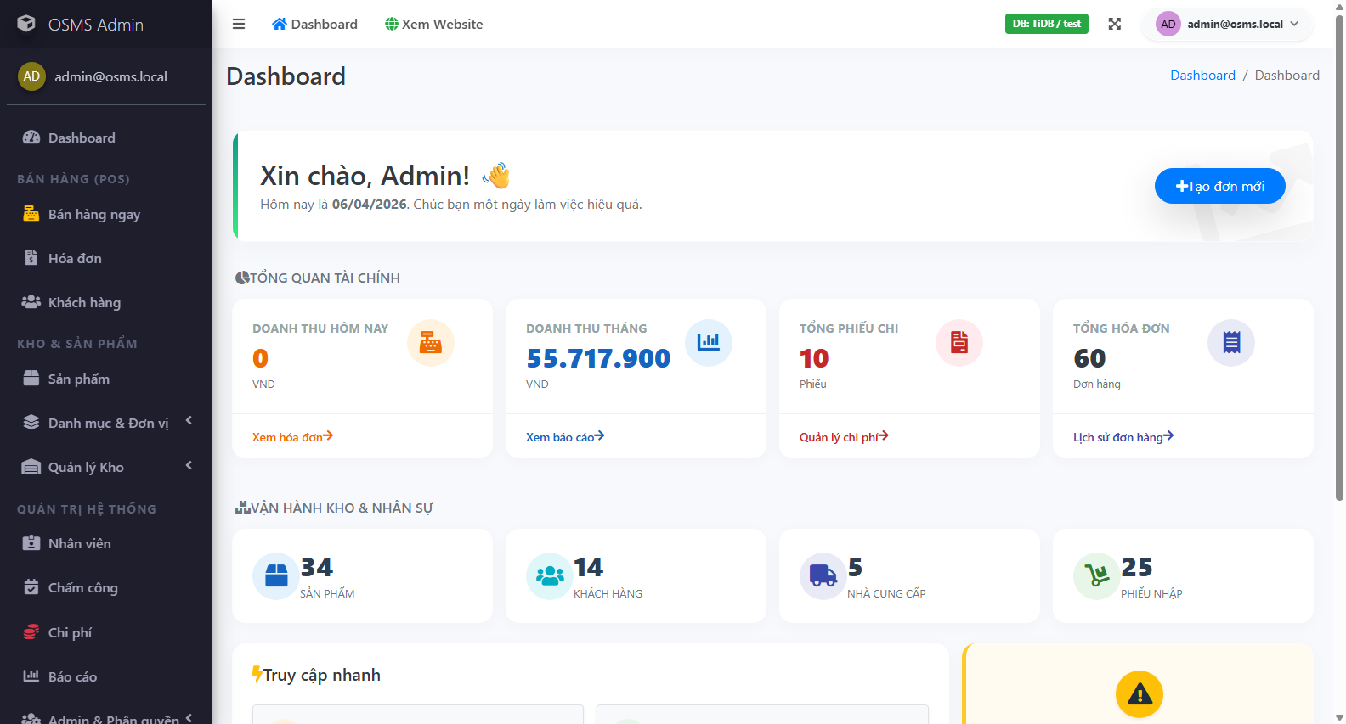
Figure 1.1. Representative administrative interface evidence after successful login to the system.

1.1.2. Main business modules
The system contains several business modules that are directly related to daily operational activities. These modules were selected as the primary testing targets because incorrect behavior in any of them could affect business continuity, inventory accuracy, transaction correctness, or access control.
The Authentication and Permissions modules control whether a user can log in successfully and whether the user can access only the functions allowed by his or her assigned role. These modules are foundational because every secured business workflow depends on them. The Products, Suppliers, and Customers modules provide core master-data management and therefore affect downstream processes such as purchases and invoices.
The Purchases and Invoices modules are the most business-critical workflows in the system. Purchase processing affects inbound stock and supplier-side records, while invoice processing affects outbound stock, payment states, and customer transactions. The Product Import module introduces additional risk because it handles multi-row validation and batch-style updates. The Stock and Reports modules are also high value because they influence operational decisions and managerial visibility. Finally, the Public Catalog module, although smaller in scope, is important because it represents the customer-facing browsing surface of the system.
Table 1.2. Main business modules
Module | Business purpose | Testing importance
Authentication | Allows valid users to access the system securely | High
Permissions / Authorization | Restricts access based on user role | High
Products | Manages product master data and sales items | High
Suppliers | Manages supplier information used by purchases | Medium
Customers | Manages customer records used by invoices | Medium
Purchases | Handles inbound stock and purchasing workflows | High
Invoices | Handles sales transactions, payment, and stock deduction | High
Product Import | Supports bulk product validation and import processing | High
Stock | Shows inventory state and stock movement information | High
Reports | Provides summary and filtered business reports | Medium
Public Catalog | Supports public browsing, filtering, and product details | Medium

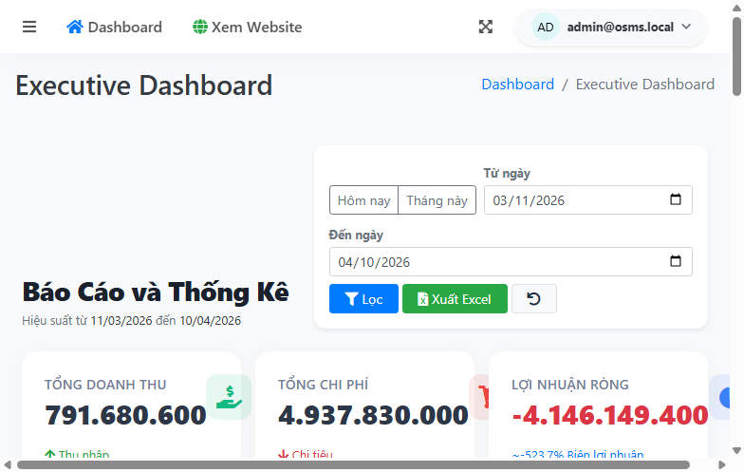
Figure 1.2. Representative administrative modules and management screens included in the test scope.

1.1.3. API overview
Although the project is primarily UI-driven, it also exposes a limited but meaningful API surface that supports monitoring and public catalog retrieval. This API layer was included in the final submission because it provides stable request-response targets that are suitable for systematic verification with Postman and Newman.
The Health API is used to confirm service availability and payload consistency. It allows the testing team to verify whether the application is running correctly and whether the returned metadata remains structurally valid. The Catalog API provides public-facing product retrieval functions, including product listing, product-detail retrieval, trending data, and filter information. These endpoints were valuable for validating status codes, response payloads, query handling, and negative scenarios such as invalid parameters or unsupported sort values.
Testing the API surface strengthens the submission in two ways. First, it complements the UI coverage by validating backend-accessible behavior directly. Second, it supports the automation bonus through a repeatable Newman execution flow with exportable results, including text output and XML runner artifacts. This makes the API section not only functionally useful but also strategically valuable for rubric coverage.
Table 1.3. API overview
API area | Purpose | Representative endpoints
Health API | Service status verification | GET /api/v1/health
Catalog product list | Public catalog retrieval | GET /api/v1/catalog/products
Catalog product detail | Single product information retrieval | GET /api/v1/catalog/products/{id}
Trending products | Returns popular or highlighted items | GET /api/v1/catalog/trending
Catalog filters | Provides available filtering metadata | GET /api/v1/catalog/filters

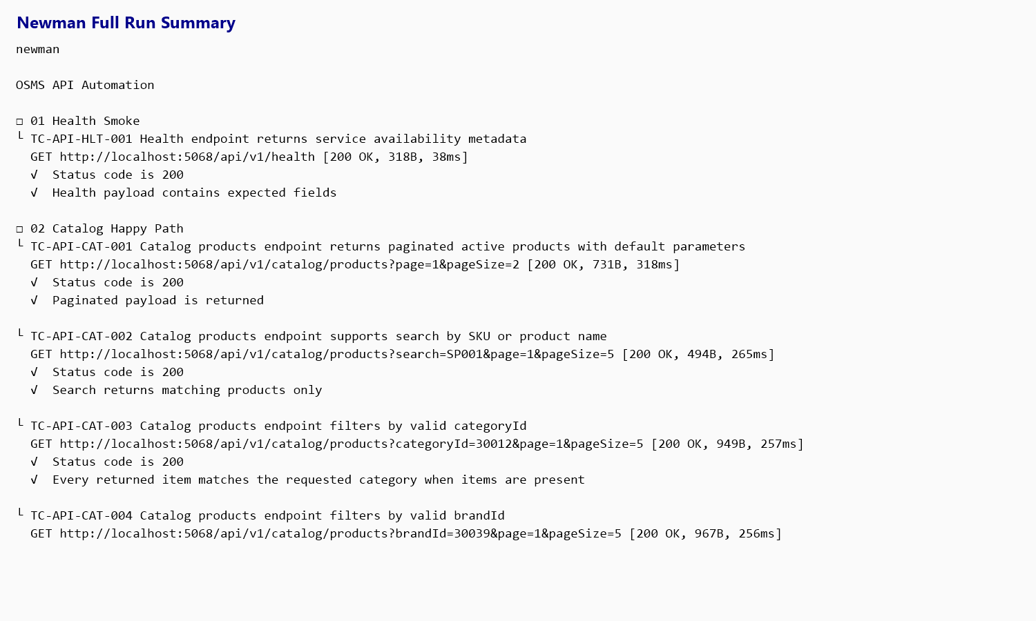
Figure 1.3. Newman execution evidence for the API test suite.

1.2. Project Team and Task Allocation
The testing project was completed by a three-member QA team. Task allocation was planned carefully to satisfy the course requirement that each member contribute at least ten non-overlapping test cases. Instead of distributing work randomly, the team assigned module ownership so that each member could focus on a specific functional area while still contributing to the integrated final submission.
This structure improved both accountability and traceability. Each member was responsible for designing, executing, and documenting test cases within clearly assigned modules. Shared artifacts such as the final report, metrics workbook, defect register, and automation evidence were synchronized only after the execution baseline had been verified. This approach reduced overlap, made evidence ownership clearer, and helped keep the final package consistent across Word, Excel, screenshots, runner outputs, and GitHub Issues.
In addition to module ownership, one member also coordinated final integration and submission consistency checks. This role was necessary because the final package includes multiple artifact types and requires strong cross-file traceability between scenarios, test cases, results, metrics, defect records, automation outputs, and presentation materials.

1.2.1. Team members
The project team consists of three members from the same class group. Each member was assigned a distinct module cluster and was required to contribute a sufficient number of individual test cases. The final workload distribution satisfies the requirement that every member owns more than ten UI test cases.
Hoang Van Thien handled the largest share of UI ownership and also led project audit, traceability alignment, and final report consolidation. Nguyen Thanh Dat focused mainly on customer, supplier, purchase, and partial stock workflows. Le Quang Duy focused mainly on product, product import, stock-related, and public-catalog-related workflows. This division created a clear separation of responsibility while preserving consistency in the final execution package.
Table 1.4. Team members
Member | Class | Student ID | Main ownership | UI cases owned
Hoang Van Thien | 22D1ITE-SWE03 | 225051915 | Authentication, Permissions, Admin Users, Admin Groups, Invoices, Reports, partial Public Catalog | 17
Nguyen Thanh Dat | 22D1ITE-SWE03 | 225050896 | Customers, Suppliers, Purchases, partial Stock | 13
Le Quang Duy | 22D1ITE-SWE03 | 225051169 | Products, Product Import, partial Stock, Public Catalog | 14

1.2.2. Responsibility matrix
To ensure non-overlapping ownership and a defendable final submission, the team used a module-based responsibility matrix. Each member was primarily responsible for the test design and execution of a specific functional area, while final integration activities were coordinated centrally to maintain consistency across all submission artifacts.
This matrix also reflects the practical reality of the project. Some deliverables, such as the final report, metrics workbook, defect synchronization, and automation packaging, required cross-member review. However, the ownership model remained clear enough that each module can be traced back to a primary contributor. This is important not only for grading compliance but also for presentation defense, where each member must be able to explain the rationale, execution, and evidence behind the parts they owned.
Table 1.5. Responsibility matrix
Work item | Primary owner | Supporting members
Project audit and scope definition | Hoang Van Thien | Nguyen Thanh Dat, Le Quang Duy
Authentication and permission testing | Hoang Van Thien | -
Admin users and admin groups testing | Hoang Van Thien | -
Invoice and report testing | Hoang Van Thien | -
Customer and supplier testing | Nguyen Thanh Dat | -
Purchase workflow testing | Nguyen Thanh Dat | -
Stock-related testing | Nguyen Thanh Dat / Le Quang Duy | Shared coverage by module split
Product testing | Le Quang Duy | -
Product import testing | Le Quang Duy | -
Public catalog testing | Le Quang Duy / Hoang Van Thien | Shared coverage by scenario split
API testing and Newman execution | QA team | Shared execution and verification
Automation framework maintenance | QA team | Coordinated integration
Final results, metrics, and defect synchronization | Hoang Van Thien | QA team
Final report and presentation consolidation | Hoang Van Thien | QA team

Overall, the team allocation satisfies the course requirements for minimum contribution, non-overlapping test ownership, and traceable responsibility. This structure also supports stronger evidence management because each module, test case set, execution artifact, and defect record can be linked back to a clearly assigned owner and a verifiable workflow.

